Objective: Estimate the value of LOL skills in winning.

Class Prep

Data

Evidence of correct data

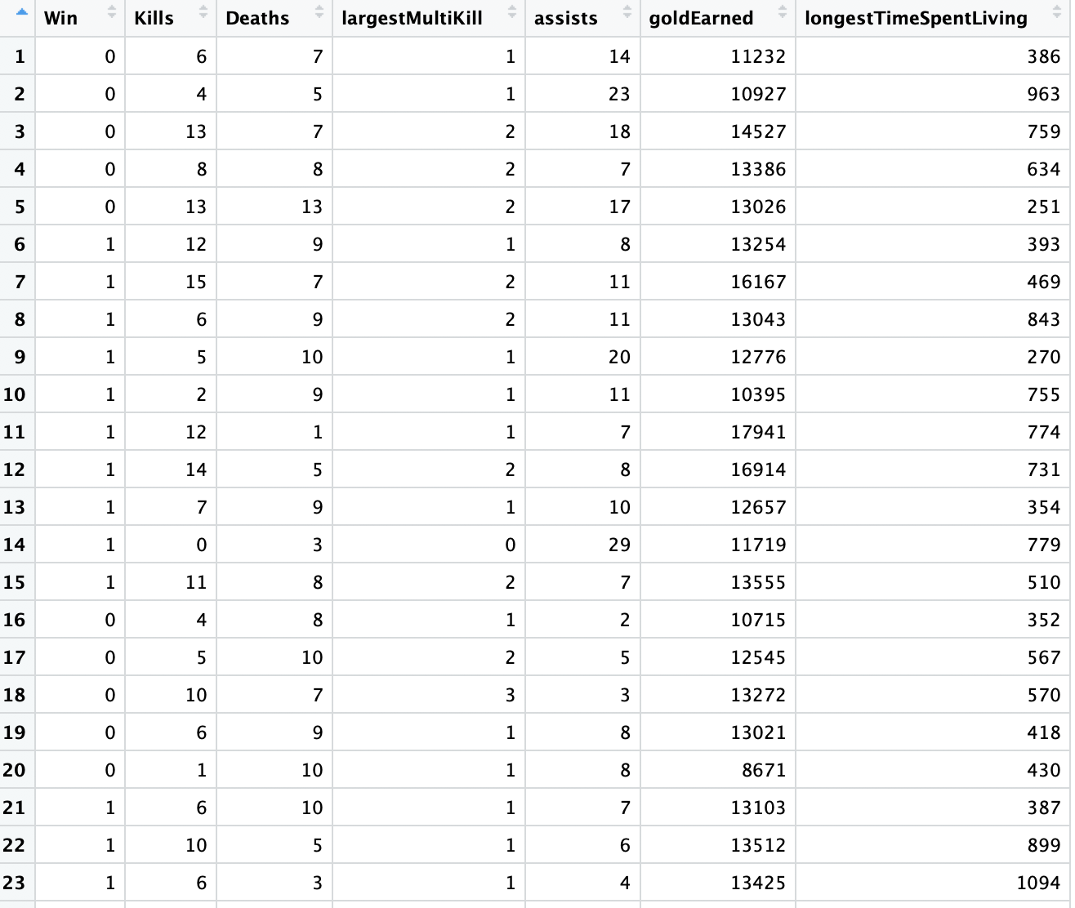

Response variable: whether or not win (Categorical)

Explanatory variables: Assists (Quantitative), Kills(Quantitative), Deaths(Quantitative), Largest Multi-Kill(Quantitative), gold Earned(Quantitative), and Longest time spent living(Quantitative).

Boxplot of Wins and Kills



Boxplot of Wins and Deaths



Boxplot of Wins and Largest Multi-kill



Boxplot of Wins and Assists



Boxplot of Wins and goldEarned



Boxplot of Wins and longesttimespendliving

